Printing from Ultra Tax SOP
Once the tax return had its final review and is ready to print and be assembled for pick up by the client.
- Prepare will assign Tax project to Admin for printing
  - TR09- Ready to print
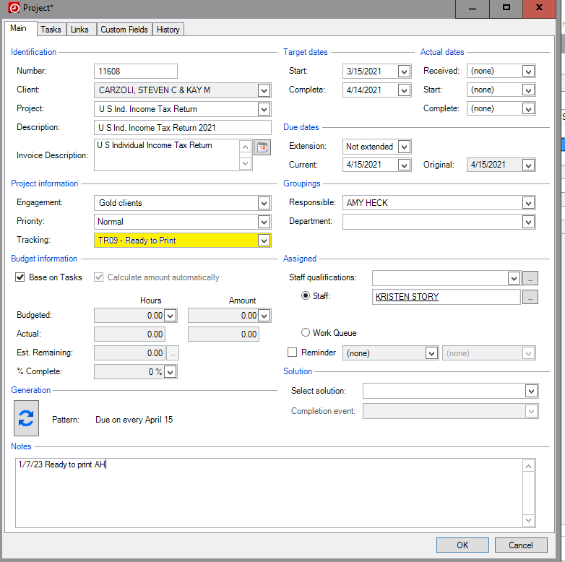
- Log in to Ultra Tax 2022
- Choose the “Folder” option at the top of the screen
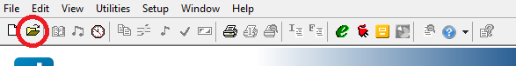
- This will open the search option to locate the assigned client
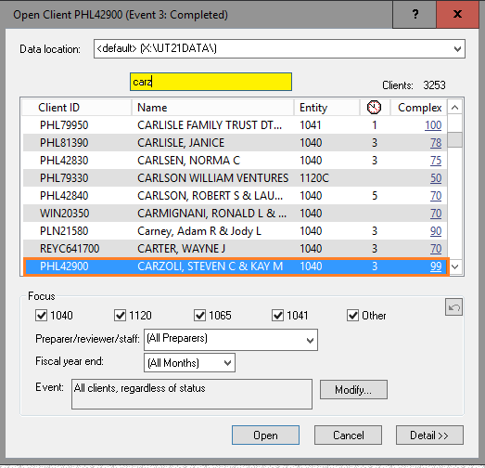
- Once client file is opened in Ultra Tax
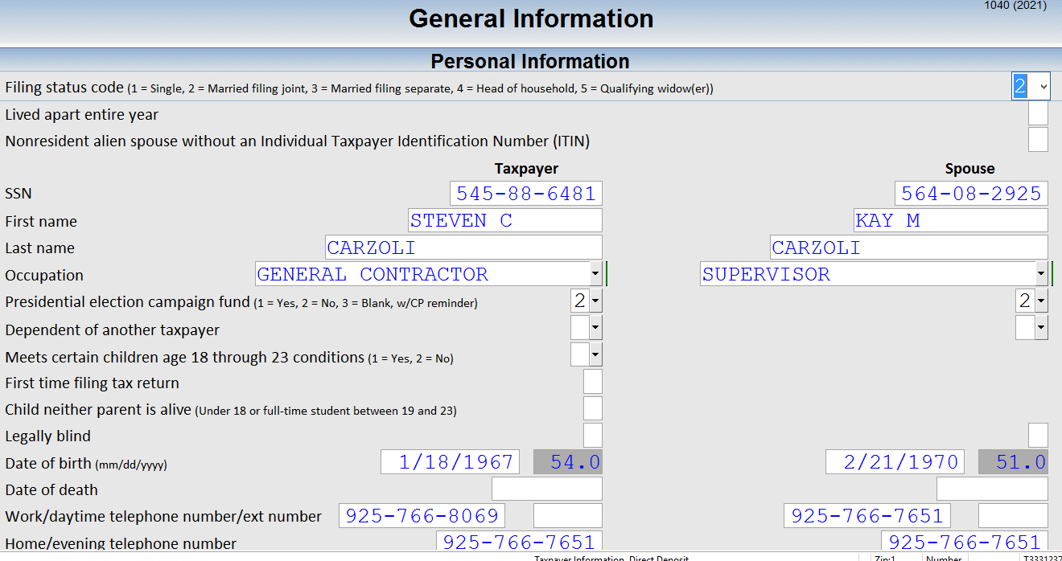

Printing Full Portal returns

- Select the contact screen on the 1040 and confirm that there are two DIFFERENT emails entered for both spouses.
- This should have been obtained at document intake.
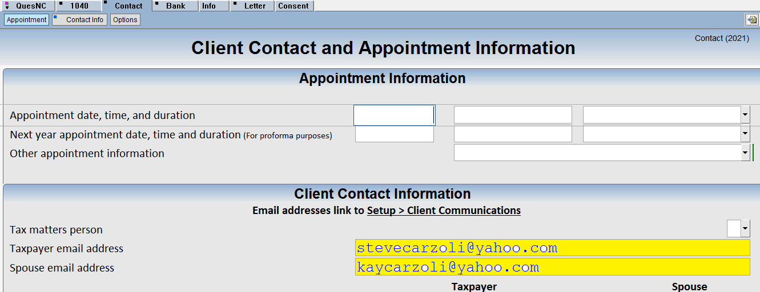

- Select the print icon in the top menu bar
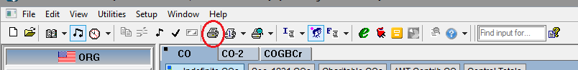
- This will open the print option box
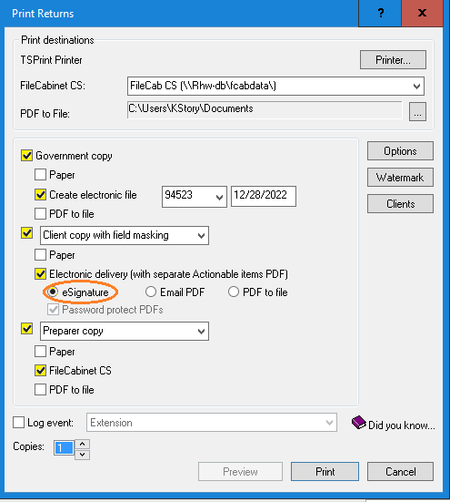
- For full portal
Select: Government copy
  - Create electronic file: Change the date to current todays date
Client Copy:
  - Create Electronic Delivery: than select eSignature
This will send the electronic signature emails to clients.

  - Preparer Copy
    - FileCabinet CS
- Choose “Print”

Hybrid Portal:
- Search for client
- Confirm two emails in contact screen

- Choose the print option in the menu bar


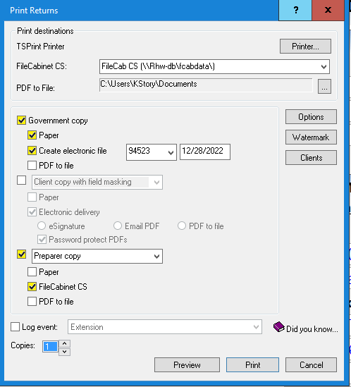
- Select: Government copy
  - Create electronic file: Change the date to current todays date
Client Copy:
  - Paper
  - Preparer Copy
    - FileCabinet CS
- Choose “Print”
- Take to assembly to be collated for pick up by client

Non Portal :
- Search for Assigned client
- Choose Print From the menu bar


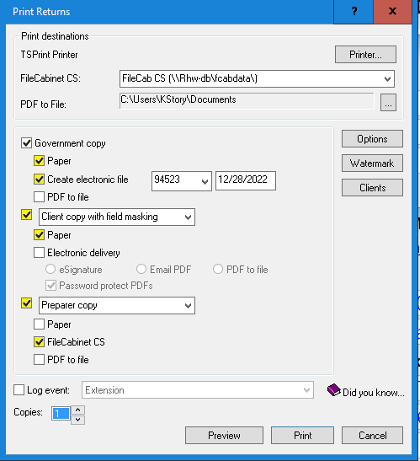
  - Create electronic file: Change the date to current todays date
Client Copy:
  - Paper

  - Preparer Copy
    - FileCabinet CS
- Packet to Assembly to be collated for client pick up

